Pubnub Dynamic Step

Objective:

It is used to publish a message in channel, so subscriber can subscribe to that channel to get notifications. PubNub is a global Data Stream Network (DSN) and real time infrastructure-as-a-service (IaaS) company based in San Francisco, California. The company makes products for software and hardware developers to build realtime web, mobile, and Internet of Things (IoT) applications.

## **UI**

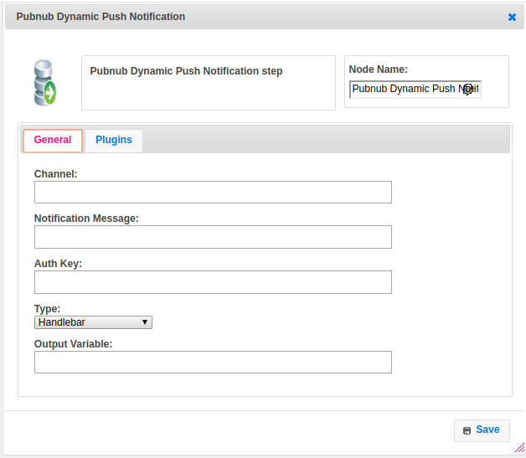

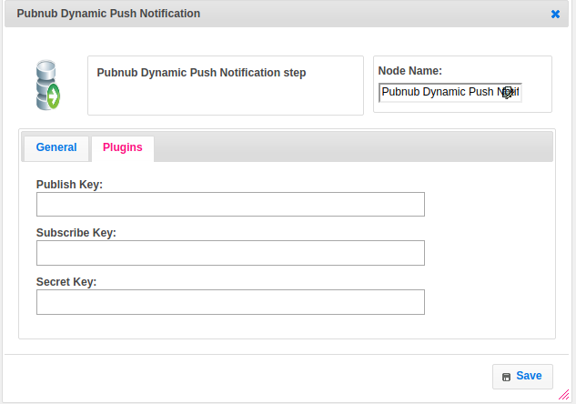

## **Attributes:**

|  |  |
| --- | --- |
| **Attributes** | **Description** |
| Channel | Messages sent through PubNub are sent on a “channel.” ... For example, each device can have its own channel, while also subscribing to a group channel, and a global channel where all devices can receive data simultaneously. |
| Notification Message | Messages are the actual packets of data that get published to channels. They can contain any serializable data, including: Objects, Arrays, Numbers and Strings. String content can include any UTF-8 character, single-byte and multibyte. Our maximum size for any single message is 32KB. The message have to be formatted as JSON, but we recommend it. It can also be any object,as long as it can be serialized; PubNub SDKs will automatically stringify JSON objects prior to publishing. Most developers use the JSON format. |
| plugin_name | The name of the plugin which we have configured earlier with publish_key, and subscribe_key |
| value_type | To select type as free marker template or handlebar |
| auth_key | The authentication is for security purpose and also it is an optional. When user wants to subscribes the channel that time need to pass the same key which we already gave in publishing to get the notification. |
| Publish key | For clients who will be publishing only, or publishing and subscribing (a client can both publish and subscribe), it will need to initialize with both the subscribeKey and the publishKey. |
| Subscribe key | The client need to initialize with subscribe key when a client only subscribe, and not to publish. |
| Secret key | associated with your other keys in your account, viewed in your account after you login to the developer's portal is used to digitally sign certain grant permissions. The Secret Key is not actually passed into the grant call, rather, it is used to initialize the PubNub object. Any PubNub object initialized with the secret-key will have the ability to grant |

## **Executor Description:**

In executor class first will subscribe the channel then authenticate the channel based on auth_key, after authentication will publish message to respective channel nad returns status as success otherwise it will throws exception as unable to publish message.

## **Resource:**

For more information please refer the below link

<https://www.pubnub.com/docs/java-se-java/api-reference-publish-and-subscribe#publish>